**Name: Parmita Patre**

**Class: Final Year B.Tech Div: B**

**Roll: B_58**

**Assignment 1**

Aim: Set up the Git Server and perform the following operations:

● Created repository:

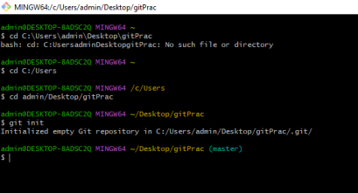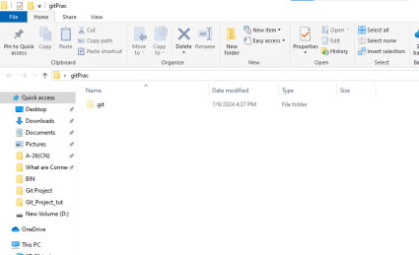

● Created a file m1.txt and added it to the staging area. Added the file to local repository by committing it:

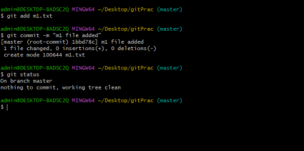

● Created a branch named b1 and switched to it from the master branch: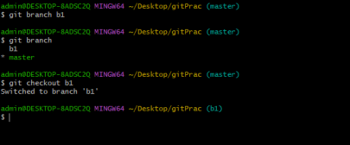

● Created another file f1.txt in branch b1 and added and committed it: 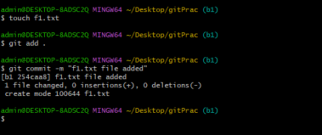

● Switched to the master branch from b1. Created another file f2.txt in the main branch and added and committed it:

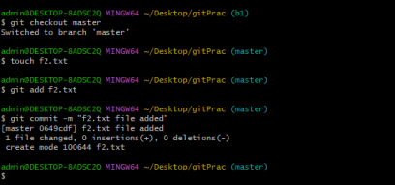

●Mergingthetwobranchesmasterandb1:

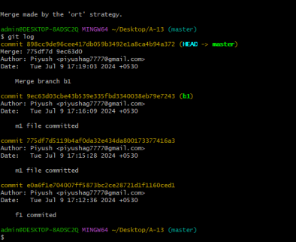

● Created a new branch b2 and rebased it with main:

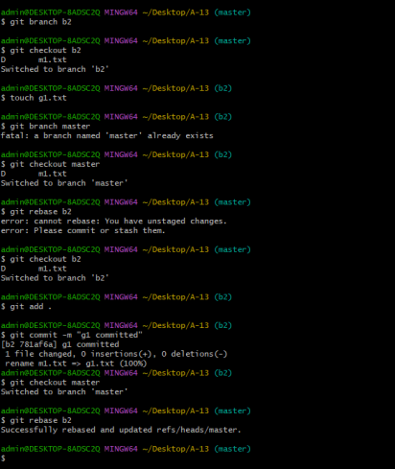

Conclusion: We have created a project and performed session management using git and also performed various operations in git.